****Essentials Mathematics

Major Test 2.9

**Topics – Time, Distance Time Graphs, Maps and Networks**

…

55

|  |  |
| --- | --- |
| **Name** |  |

* **Attempt all questions**
* **Show all working and calculations where possible**
* **Calculators are allowed**
* **One A4 page of notes is allowed**
* ***You must include all working out to receive full marks***

**Question 1 (5 marks: 1, 1, 1, 1, 1)**

Jade travels from her home to Fremantle to go to work. The graph shows the distance Jade was from Fremantle as she travelled to work on Friday. Jade left home at 9:00 am to drive to Fremantle. She stopped at a café for a quick breakfast with her friend Aden. After breakfast, Jade dropped Aden back at his house before she continued her journey to work.



1. What was Jade’s average speed on the way to the café in km/h?
2. How long did Jade and Aden take to have breakfast?
3. At what time did they leave the café?
4. How far does Aden live from the café?
5. After dropping off Aden, what was Jade’s average speed on the way to Fremantle in km/h?

**Question 2 (7 marks: 2, 2, 1, 2)**

The network below shows the road connections, in kilometres, of some South-West towns.



1. After playing golf in Collie, Jack wants to travel to Katanning. What is the shortest road distance from Collie to Katanning?
2. Which towns would he pass through if he travels the shortest route?
3. If petrol costs Jack 14 cents per kilometre by car, calculate the cost of his petrol for this shortest route.
4. Jack has heard there is a good restaurant at Arthurs River and wants to stop there for a break. What is now the shortest path and distance Jack can travel from Collie to Katanning?

**Question 3 (2 marks)**

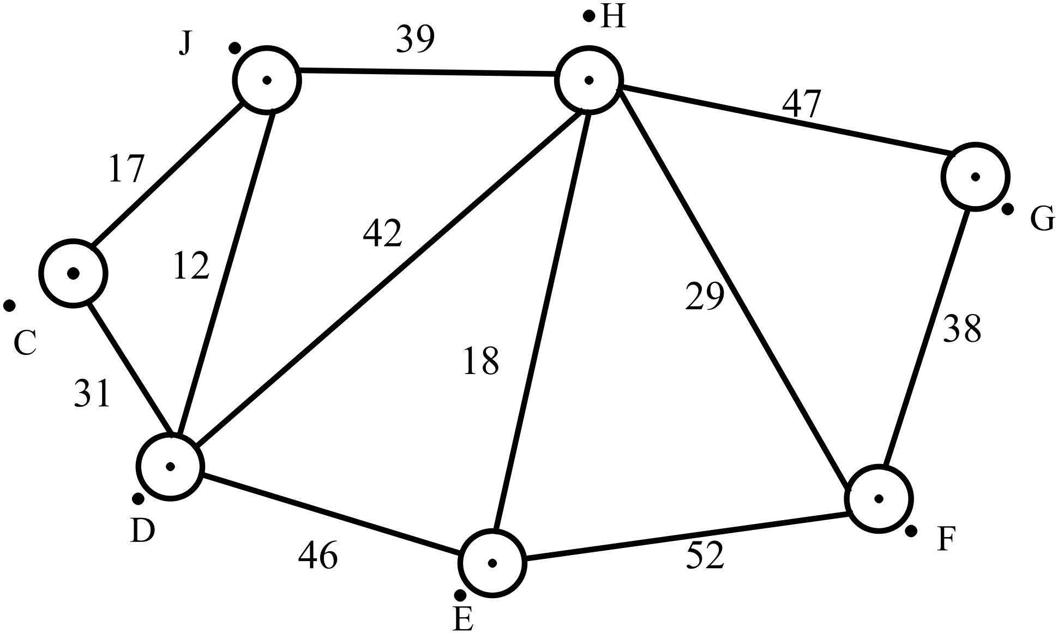

1. Showing your working on the diagram, determine the shortest path from C to G, stating the path and the distance.
2. Is it possible to travel all the paths in the network without retracing or missing paths? If so, give the route you use, if not, explain why not.

**Question 4 (15 marks)**

You are to draw a travel graph on the following set of axes to represent the movements of Gabby last Tuesday.

Gabby left home at 10am, walking to her friend’s house. Twenty minutes after starting, 2km from home, she realized she had left her phone at home, so turned around to go back to get it. She walked at the same pace for 10 minutes until her phone rang in her pocket!!!!!!!!! She turned around again, heading for her friend’s house. She jogged the 3km in 20 minutes.

Gabby needed a drink and a good sit down after all that effort, so she and Halle made banana smoothies, drank and chatted. At noon, Halle’s Mum drove them the 6km out of town to the court for basketball training. They only took 10 minutes to get there.

Halle’s Mum picked them up at 3pm, driving Gabby straight home. The drive took 20 minutes in the afternoon rush.



**Question 5 (6 marks)**

This is the timetable for the Rottnest Express ferry.

Timetable Travelling to Rottnest Island Friday, October 30, 2015

|  |  |  |  |
| --- | --- | --- | --- |
| **Boarding Closes** | **From** | **To** | **Remarks** |
| 07:15 | B-Shed Fremantle | Rottnest Island | Direct service from B Shed to Rottnest |
| 08:30 | Barrack St, Perth | Rottnest Island | Service travels from Perth via Northport to Rottnest |
| 10:00 | Northport Fremantle | Rottnest Island | Service travels from Perth via Northport to Rottnest |
| 09:30 | B-Shed Fremantle | Rottnest Island | Direct service from B Shed to Rottnest |
| 11:30 | B-Shed Fremantle | Rottnest Island | Direct service from B Shed to Rottnest |
| 13:45 | Northport Fremantle | Rottnest Island | Direct service from Northport to Rottnest |
| 15:15 | B-Shed Fremantle | Rottnest Island | Direct service from B Shed to Rottnest |
| 17:45 | B-Shed Fremantle | Rottnest Island | Service travels from B Shed via Northport to Rottnest |
| 18:15 | Northport Fremantle | Rottnest Island | Service travels from B Shed via Northport to Rottnest |

Timetable Travelling from Rottnest Island Friday, October 30, 2015

|  |  |  |  |
| --- | --- | --- | --- |
| **Boarding Closes** | **From** | **To** | **Remarks** |
| 08:25 | Rottnest Island | Northport Fremantle | Service travels to B Shed via Northport |
| 08:25 | Rottnest Island | B-Shed Fremantle | Service travels to B Shed via Northport |
| 10:40 | Rottnest Island | B-Shed Fremantle | Direct service to B Shed |
| 11:40 | Rottnest Island | Northport Fremantle | Direct service to Northport |
| 14:10 | Rottnest Island | Northport Fremantle | Service travels to B Shed via Northport |
| 14:10 | Rottnest Island | B-Shed Fremantle | Service travels to B Shed via Northport |
| 15:55 | Rottnest Island | Northport Fremantle | Service travels to Northport, B Shed and Perth |
| 15:55 | Rottnest Island | B-Shed Fremantle | Service travels to Northport, B Shed and Perth |
| 15:55 | Rottnest Island | Barrack St, Perth | Service travels to Northport, B Shed and Perth |
| 16:25 | Rottnest Island | B-Shed Fremantle | Direct Service from Rottnest to Bshed |
| 19:10 | Rottnest Island | B-Shed Fremantle | Service travels to Northport via B Shed |
| 19:10 | Rottnest Island | Northport Fremantle | Service travels to Northport via B Shed |

All times in Australian Western Standard Time.

<https://www.rottnestexpress.com.au/ferry-timetable>

1. Pauline hopes to park her car at Northport while she spends the day at Rottnest. Which ferries should she choose to allow maximum time on the island?
2. Gary intends to catch a bus to Barrack St in Perth to allow him to catch the ferry. Which ferries should he use to allow himself maximum time on the island?
3. Claudia has a dentist appointment at 10am, then plans to go to B shed to catch a ferry. Which ones can she catch to spend the most time on Rottnest?

**Question 6 (14 marks)** WA police provided the information below.

[**http://www.police.wa.gov.au/Default.aspx?TabId=1073&mid=1611&SkinSrc=[G]Skins/WAPoliceHome/WAPoliceHome&ContainerSrc=[G]Containers/PrintVersionContainer/MyPrintContainer&dnnprintmode=true**](http://www.police.wa.gov.au/Default.aspx?TabId=1073&mid=1611&SkinSrc=%5bG%5dSkins/WAPoliceHome/WAPoliceHome&ContainerSrc=%5bG%5dContainers/PrintVersionContainer/MyPrintContainer&dnnprintmode=true)

# Crash statistics

Provided for your information and to raise awareness in our community to the waste of our most valuable resource.

## Fatalities (year to date) - as at 11:59pm, 21 October 2015

|  |  |  |  |
| --- | --- | --- | --- |
| **Year** | **Metro** | **Country** | **Total** |
| 2015 | 58 | 70 | 128 |
| 2014 | 71 | 77 | 148 |
| 2013 | 67 | 59 | 126 |
| 2012 | 69 | 77 | 146 |

## Critical Injuries (year to date) - as at 11:59pm, 21 October 2015

|  |  |  |  |
| --- | --- | --- | --- |
| **Year** | **Metro** | **Country** | **Total** |
| 2015 | 71 | 67 | 138 |
| 2014 | 116 | 82 | 198 |
| 2013 | 91 | 70 | 161 |
| 2012 | 72 | 86 | 158 |

1. From the data given, which year had the lowest number of fatalities?
2. For 2015 so far, what percentage of fatalities have been on country roads?
3. For 2015 so far, what percentage of critical injuries have been on country roads?
4. Comment on the fatalities and critical injuries on country roads, how do they compare?
5. Is it possible to effectively compare results of 2015 to the other years? Explain.
6. By what percentage did the critical injuries increase between 2012 and 2014?
7. Assuming we have the same rate of fatalities over the remaining 2 months of 2015, how many fatalities will we expect for this year on WA roads?

**Question 7 (6 marks)**

Graham has a chainsaw that uses a petrol to oil ratio of 50:1 and a mower that uses a ratio of 25:1.

1. How much oil does he need to add to 2L of petrol to use in the chainsaw?
2. How much oil does Graham need to add to the 3L can of petrol to use for the mower?
3. If Graham has fuel made up for the chainsaw, is he able to use this for the mower? Explain.

END OF TEST